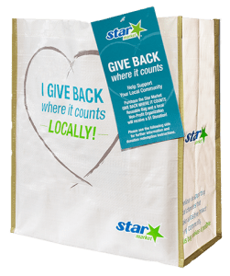

GIVE BACK WHERE IT COUNTS
REUSABLE BAG PROGRAM

Fact Sheet

Congratulations on your organization’s selection in the Star Market Give Back Where It Counts Reusable Bag Program!

Not sure how to start talking about the program? We’re here to help! We’ve brought together key facts and talking points from across the program website compiled in one place. Below you will find information you can use to discuss this program with your board, staff, and supporters:
- The Star Market Give Back Where It Counts Reusable Bag Program has been operating since March 20, 2019.
- Since inception, the program has donated $140,558 to 397 nonprofit organizations and sold 140,558 reusable bags.*
- Star Market operates 23 stores across Massachusetts. All stories participate in the program.
- The Star Market Give Back Where It Counts Reusable Bag Program makes it easy for shoppers to support their communities and environment by buying durable, reusable shopping bags. A portion of each purchase goes to a local nonprofit organization focused on Education (all aspects), Health & Wellness, Hunger Relief, Civic activities, or Military/Veterans activities.
- Every month, the Store Leadership Team at each Star Market location chooses a local nonprofit to be the monthlong beneficiary of the Give Back Where It Counts Reusable Bag Program in that store. Different nonprofits are selected every month to ensure the many organizations making a difference in our local communities can be supported by this program. The name of the organization is displayed on the reusable bag rack during their benefiting month.
________________________________________
*As of 5.03.2025. These statistics are updated regularly on the program website and can be found here. You will want to use the most recent stats available at the time of your selection.

Page 2

- Generally, the nonprofits selected by a specific store are within a 10-mile radius of that store location. It’s important to note that this program benefits each store’s regional shopping area.
- Each bag costs $3.00, with $1 of that purchase going to support a benefiting nonprofit in your community.
- Nonprofits meeting the program's qualifications are submitted to our database of thoroughly researched organizations within the vicinity of each store location
- A list of nonprofit organizations that have benefited from the Give Back Where It Counts Reusable Bag Program can be found here on the program website and is organized alphabetically.
- The bags are made from 95% recycled materials from either nonwoven or woven polypropylene. They are manufactured in Vietnam in factories that follow the strictest guidelines for employment and production standards.
Published 5.12.2025.

