
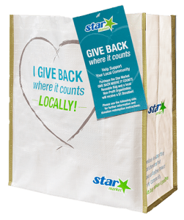
GIVE BACK WHERE IT COUNTS
REUSABLE BAG PROGRAM

Announcement Email

& Social Post

SUBJECT LINE: We’ve been selected to partner with the Star Market GIVE BACK WHERE IT COUNTS Reusable Bag Program!

PREVIEW TEXT: During [Month], we receive $1 for every GIVE BACK WHERE IT COUNTS Reusable Bag purchased at our selected Star Market location!

Dear [Staff/Board/Volunteers/Supporters],

We are excited to share that Star Market has selected [organization] to benefit from the GIVE BACK WHERE IT COUNTS Reusable Bag Program throughout [month]. The Star Market GIVE BACK WHERE IT COUNTS Reusable Bag Program makes it easy for shoppers to contribute to their local communities.

Every time a $3.00 reusable GIVE BACK Bag is purchased at the Star Market located at [location] in [month], $1 will be donated to [organization]. This is a great way to broaden awareness of our mission and help our cause.

Let’s get started! Share the news with friends and family. Call, send emails, and post on social media. The more people who purchase a GIVE BACK Bag in [month], the greater the donation we will receive from Star Market!

For information about the program, please visit starmarket.2givelocal.com.

Best,
[Signature]





Share With Your Followers

We’re excited that Star Market has selected our organization to benefit from the GIVE BACK WHERE IT COUNTS Reusable Bag Program! Throughout [month], we will receive a $1 donation for every $3.00 reusable GIVE BACK Bag purchased at the Star Market located at [address of selected store(s)].

